

Usecase Diagram Output

Mentorhub system

YPP3 | 23/05/2024

Contents

I/ Contribution table 2

II/ Use-case Diagram 3

1. LMS Subsystem 3

2. Program Management Subsystem 4

3. DAM Subsystem 5

4. Certification Management Subsystem 6

5. Mentoring Hub Subsystem 7

6. Job Market Subsystem 8

7. Social Subsystem 9

8. Communication Subsystem 10

# I/ Contribution table

|  |  |
| --- | --- |
| Use-case diagram | Assignees |
| 1. LMS Subsystem (Update) | Tai Dang, Khoa Nguyen |
| 1. Program Management Subsystem | Khoi Nguyen, Bao Ly |
| 1. DAM Subsystem | Quang Nguyen, Thinh Vo |
| 1. Certification Management Subsystem | Ngoc Le, Nhi Le |
| 1. Mentoring Hub Subsystem (Update) | All |
| 1. Job Market Subsystem | All |
| 1. Social Subsystem | All |
| 1. Communication Subsystem | All |

# II/ Use-case Diagram

## LMS Subsystem

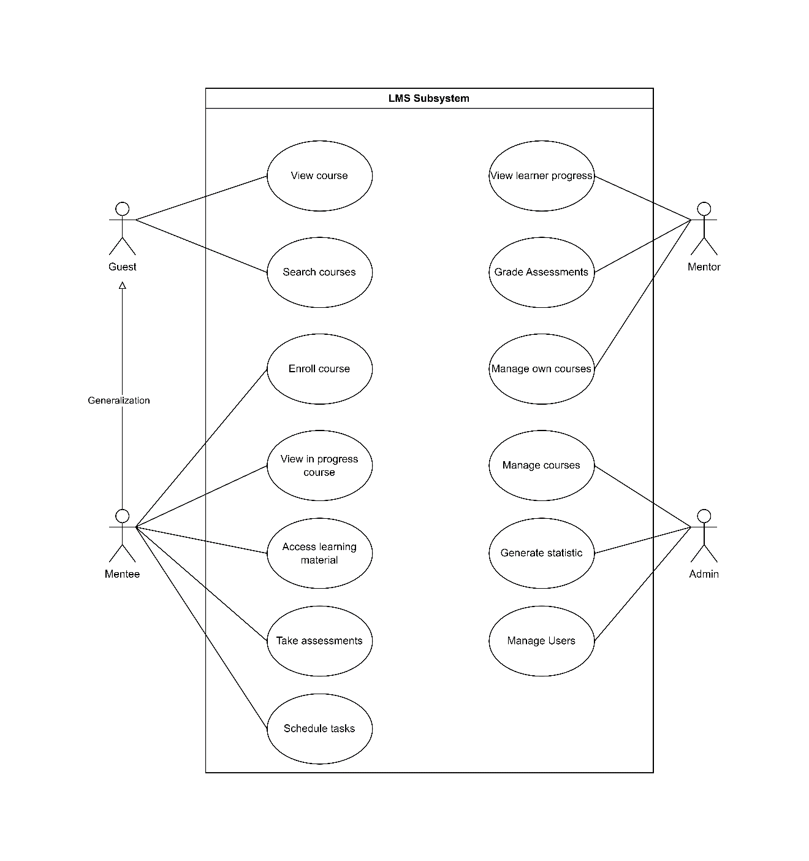

## Program Management Subsystem

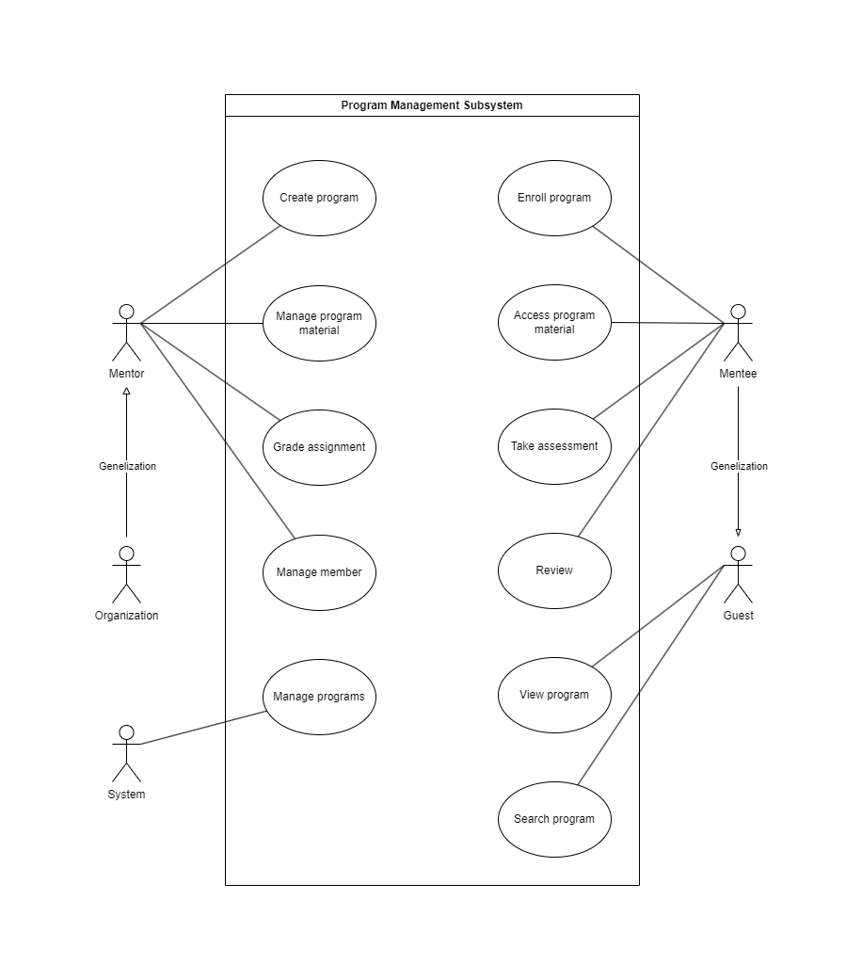

## DAM Subsystem

In this usecase diagram ( DAM Subsystem ) actor users mean Mentor, Mentee and Organization.

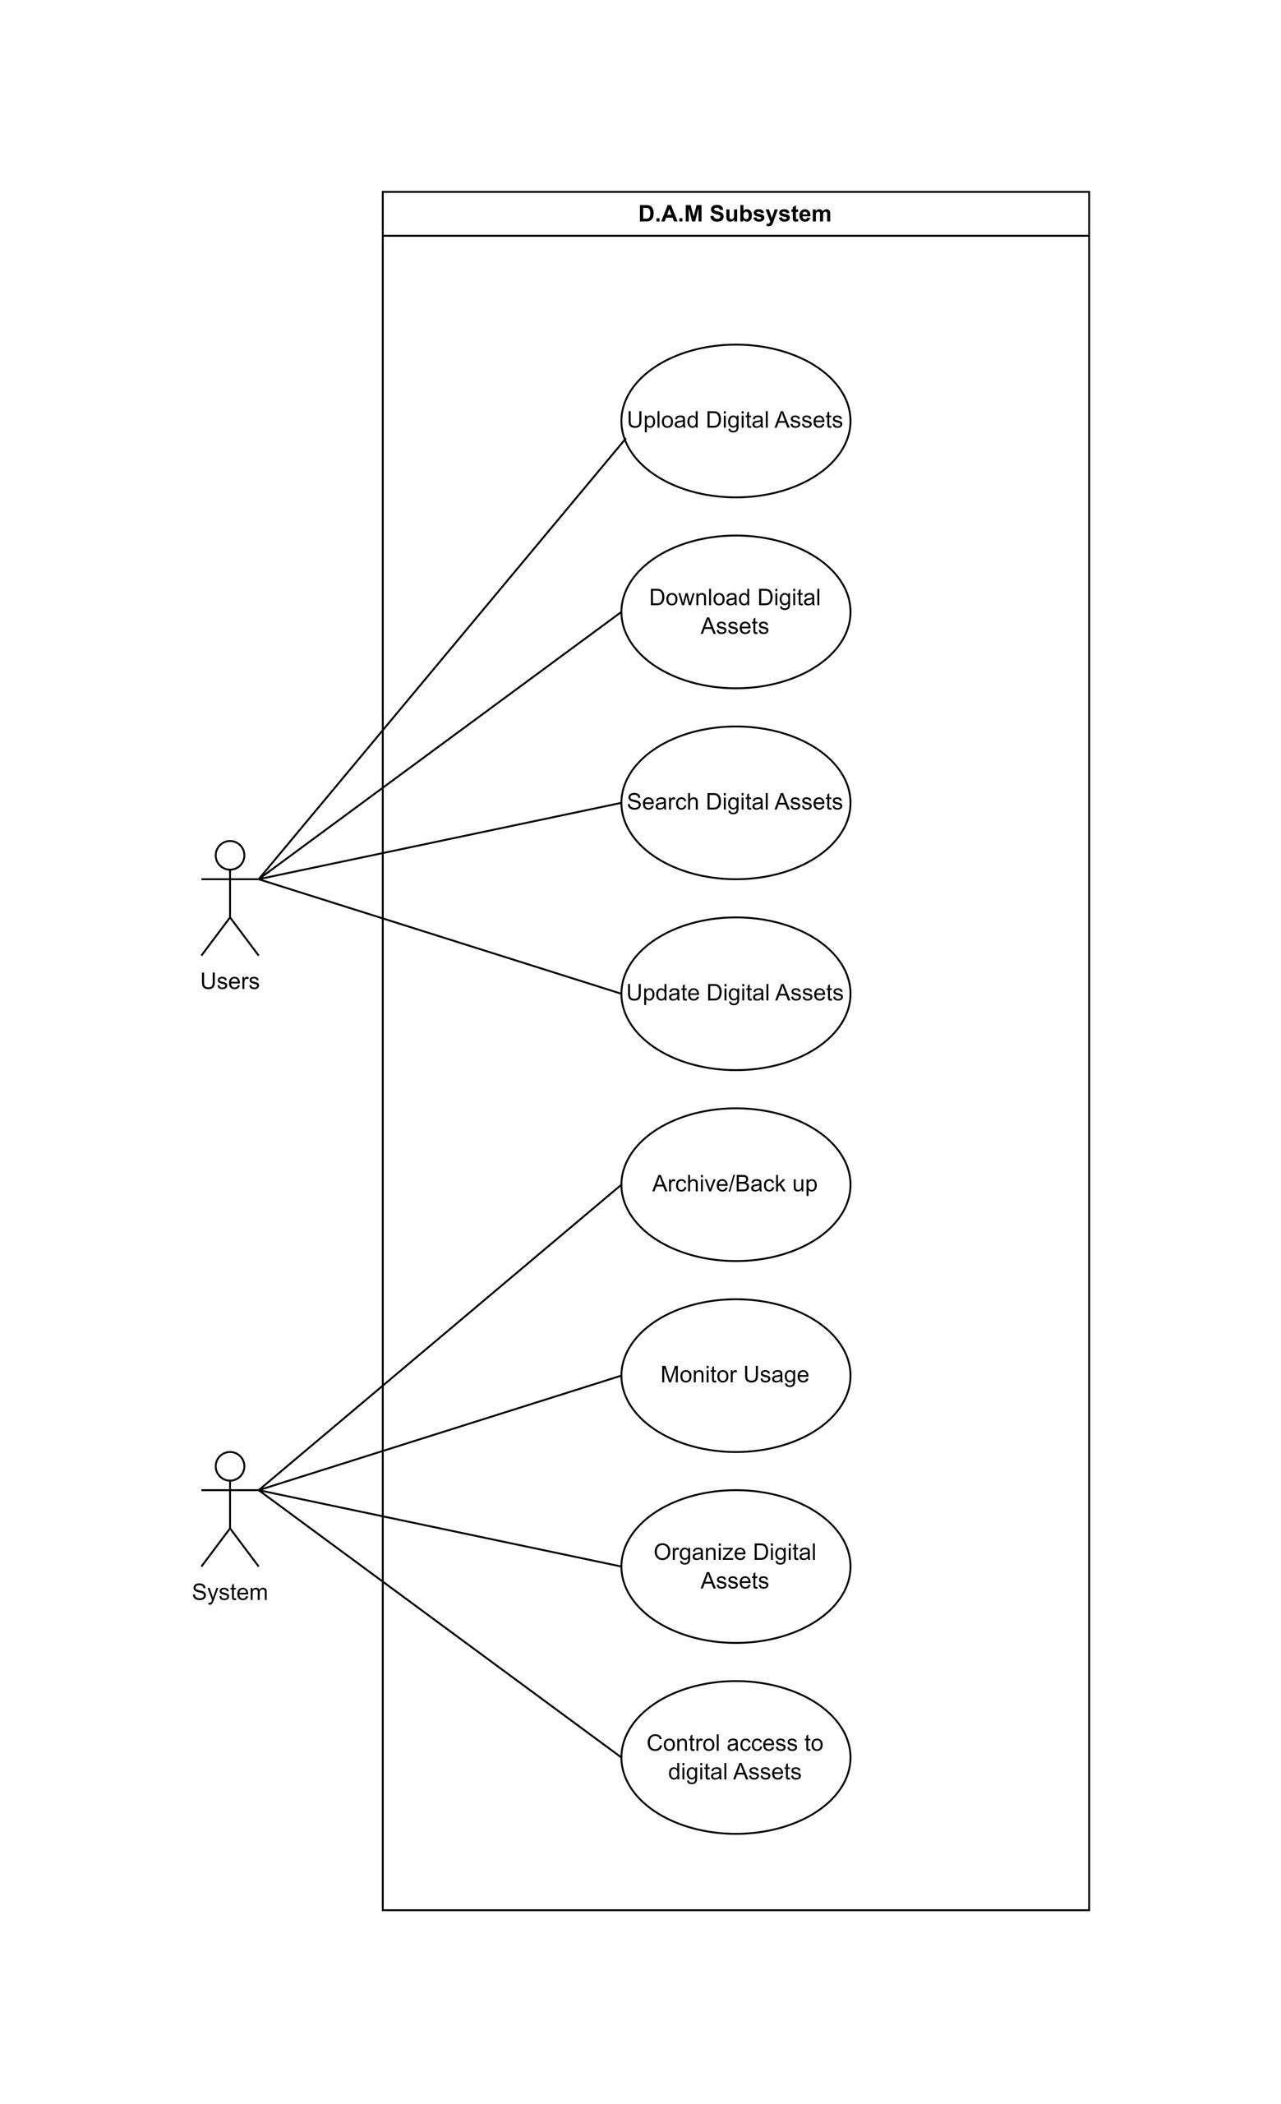

## Certification Management Subsystem

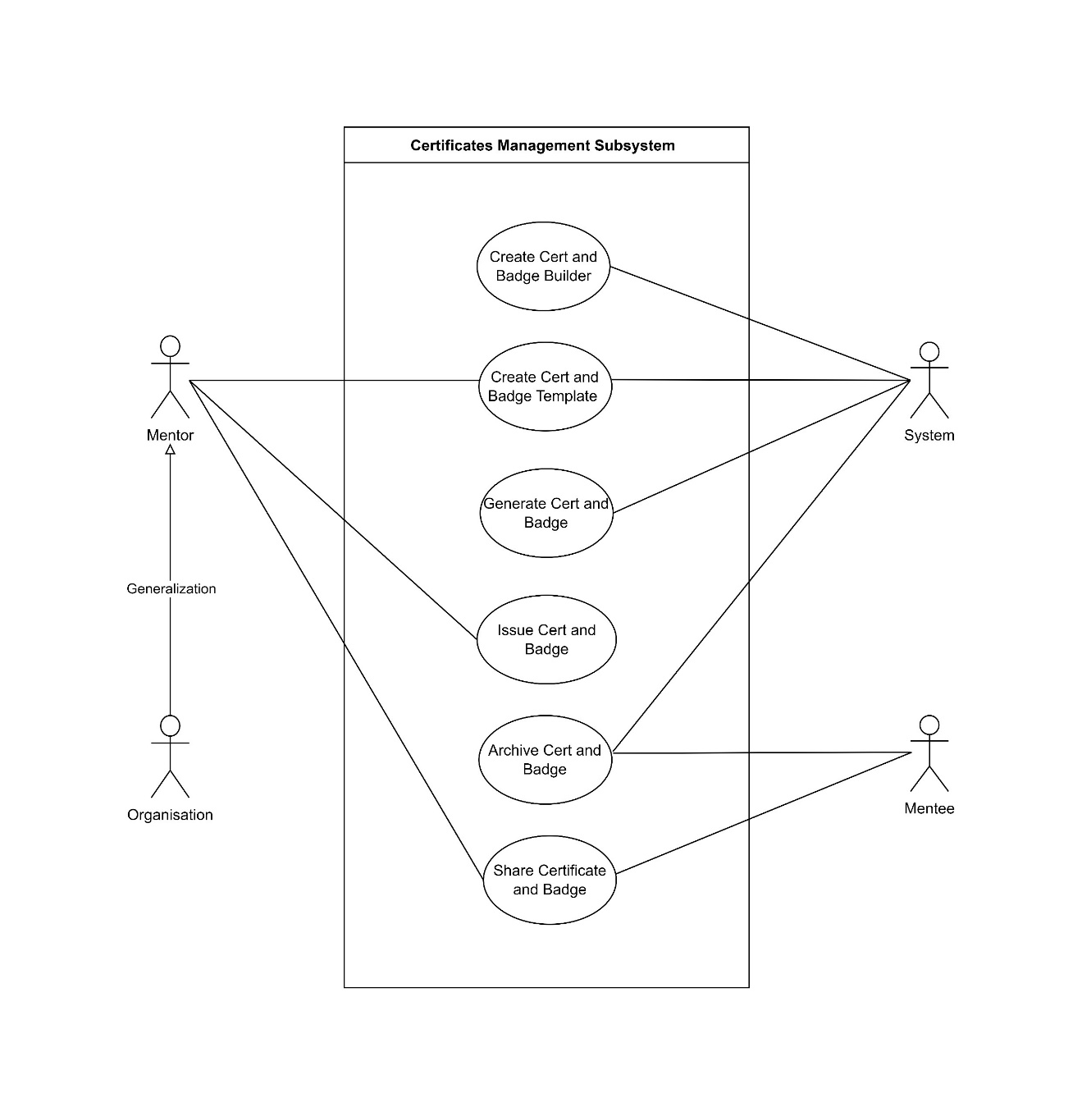

## Mentoring Hub Subsystem

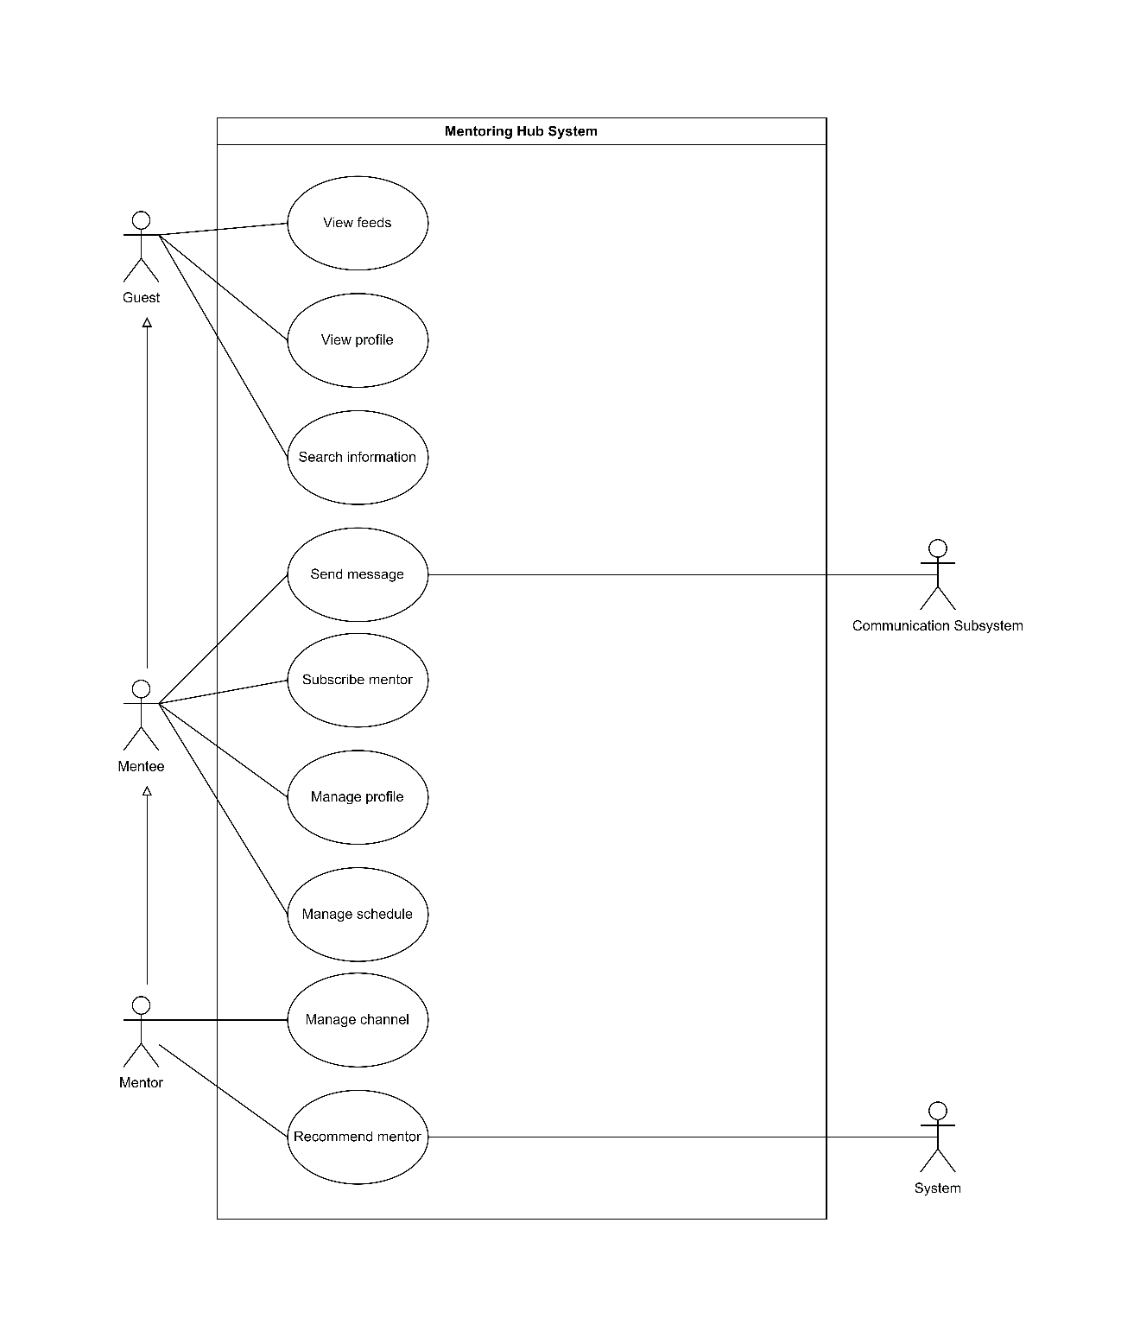

## Job Market Subsystem

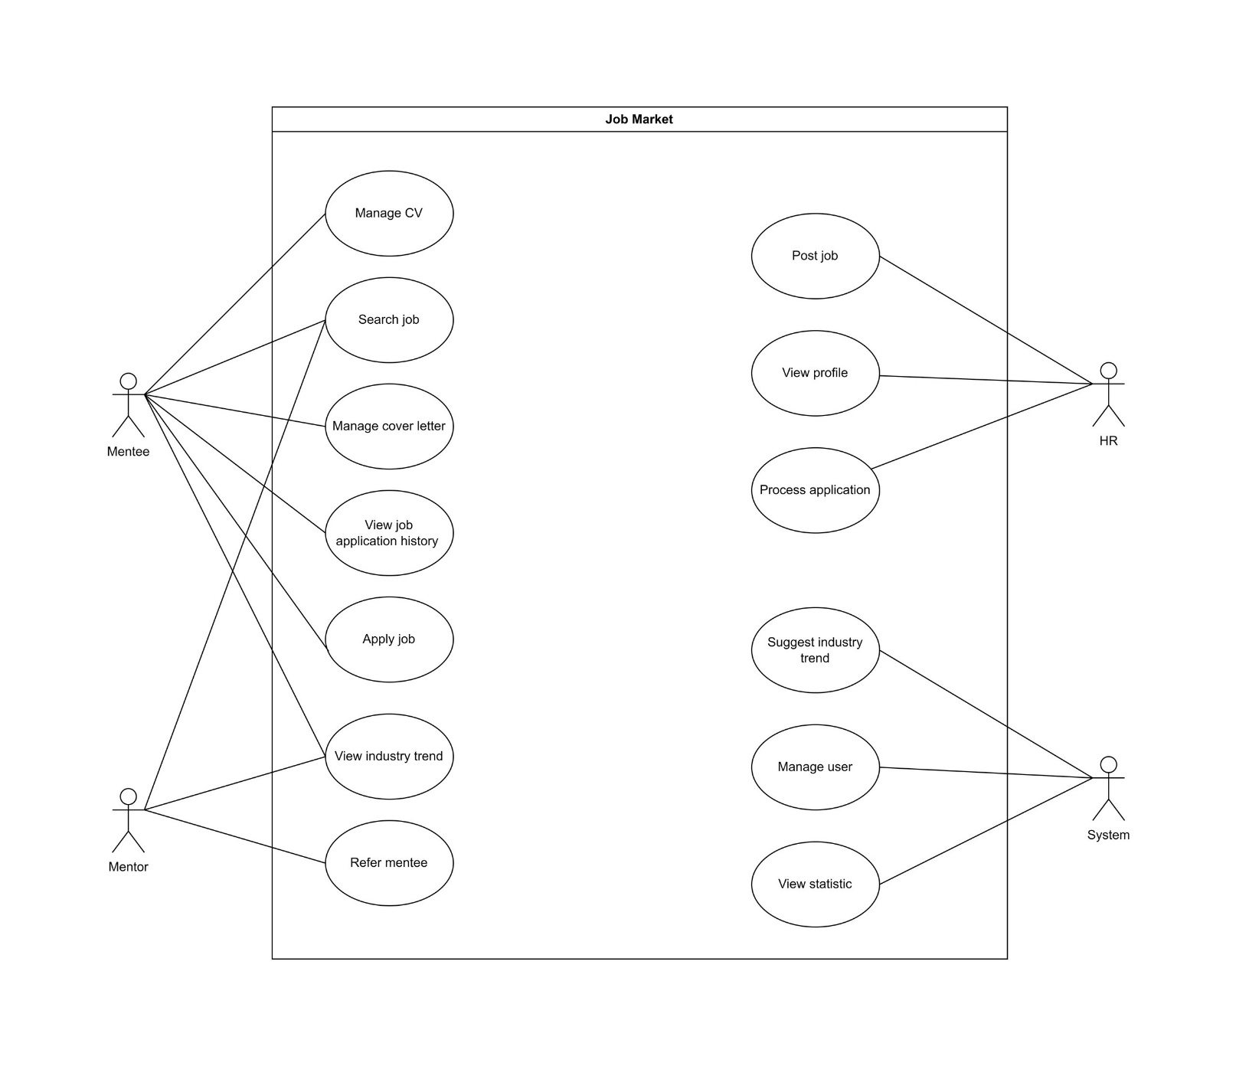

## Social Subsystem

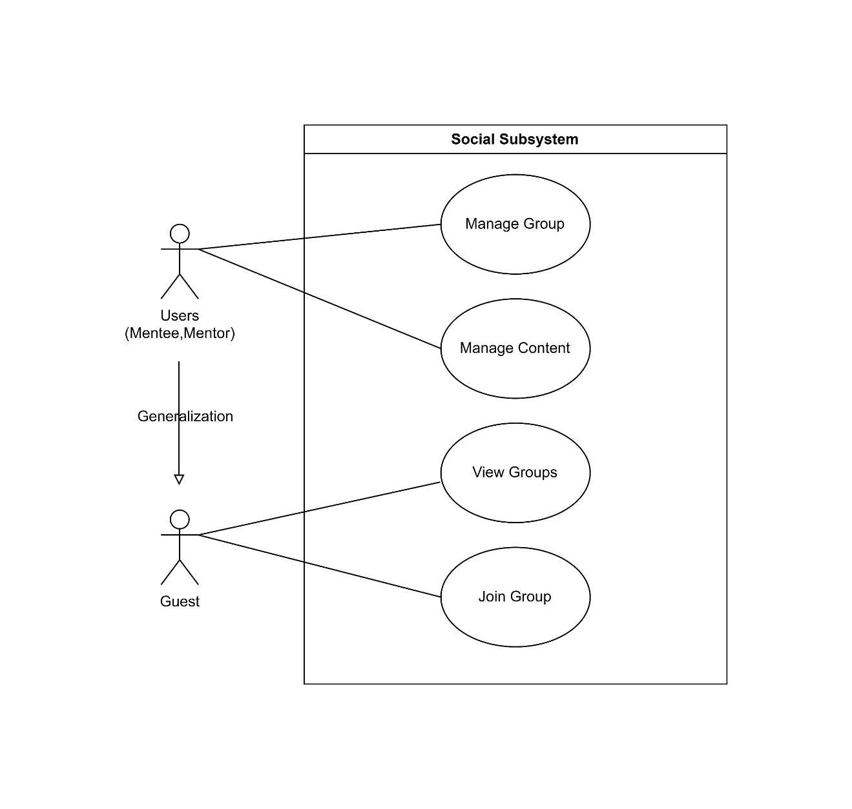

## Communication Subsystem

